Updated checklist for Digital Signature Certificate (DSC) form (Jan 2016)

Note: - Use only Blue Ink to sign the application Form & for attestation on Documents.

Very Important: DSC Application form should be filled in consultation with ACE personnel; a scanned copy can be shared on email prior dispatching to our office. All needful changes should be done before sending them to our office.

 |  |  |  |  |  |  |  |  |  |  |  |  |  | Ref. No.: - ___________ |  |  |  | e KYC |  |  | non e KYC
 | Applicant |  |  |  |  |  |  |  |  |  |  |  |  | Purpose or use of
 | Name |  |  |  |  |  |  |  |  |  |  |  |  | DSC
 | Organization |  |  |  |  |  |  |  |  |  |  |  |  | Department Name /
 | Name |  |  |  |  |  |  |  |  |  |  |  |  | Nature of Business *
 | Chq. No. |  |  |  |  |  | Amt.:- |  |  |  |  |  |  | Website: Where
 | Chq. No. |  |  |  |  |  |  |  |  |  |  |  |  | DSC to be Used
 | Enrollment |  | By Ace |  | By Applicant |  |  |  | By ___________ |  |  |  |  | Certificate Type: | Signing |  | Encryption |  |  |  | Sign. + Encryption
 | DSC Class: |  | Class 2 |  | Class 3 | Validity : |  |  | 1 Year | 2 Years |  |  |  | Token: | Token needed |  |  | Already have Token
 | Delivery address for DSC:
 | Option 1 |  |  | Applicant producing a finger touch on biometric device and thereby linking on the AADHAR database for e KYC
 |  |  |  | confirmation and supporting the Organization documents in case of Organization type DSC. This option will definitely
 | e KYC
 |  |  |  | save your valuable time and help you to obtain Digital signature at an ease.
 | Id proof |  |  | UID (AADHAR), PAN, Driving License, Id card issued by State or Central Govt. Deptt.
 | Address proof |  |  | Any one from below detailed lists for option 2 (Required only for Organization type DSC only)
 | Organization Proof |  |  | For e-KYC organizational type, the required documents will be the same as for Non-eKYC.
 | Option 2 |  |  | Conventional application form on paper supported with appropriate KYC attested documents; followed by confirmation
 |  |  |  | through SMS and e mail verification for class 2 and for class 3 - Video clip uploaded on Sify Safescrypt web site. Table
 | Non e KYC
 |  |  |  | below mentions detailed KYC documents list and important points are mentioned.
 | Applicant’s Identity proof |  |  |  |  |  |  | Address proof For |  |  |  |  |  | Organization Documents for Non- |  |  | Documents required for Company
 | (Any One) |  |  |  |  |  |  | Individual type DSC |  |  |  | Government Organization / Trust - Proof |  |  |  |  |  | Type DSC for Public or Private
 |  |  |  |  |  |  |  | (Any One) |  |  |  |  |  | of Right to do Business (POR) |  |  | Limited Company (POR) Proof of
 |  |  |  |  |  |  |  |  |  |  |  |  |  | (All Documents required) |  |  |  | Right to do Business (POR)
 |  |  |  |  |  |  |  |  |  |  |  |  |  |  |  |  |  | (All Documents)
 | • Applicant PAN Card (Mandatory) |  |  |  |  |  | • | Aadhar Card |  |  |  | • PAN Card of NGO/Trust |  |  |  |  | Corporate Entities:
 | • Govt. Department Id Card (Mandatory |  |  |  |  |  | • | Voter ID Card |  |  |  | • | Incorporation and Registration Certificate |  |  |  | • Copy of Company Pan Card
 | for Govt. Employees) |  |  |  |  |  | • | Mobile / Telephone bill |  |  |  |  | issued by authority such as Registrar /sub- |  |  |  | • Copy of certificate of incorporation
 | • Passport |  |  |  |  |  |  | /Gas connection |  |  |  |  | assurances |  |  |  | • Copy of Article and Memorandum
 | • Driving License |  |  |  |  |  | • | Electricity bill / Water |  |  |  | • | Copy of Trust Deed |  |  |  |  | of Association (First two page)
 | • Bank Account Passbook containing the |  |  |  |  |  |  | Bill |  |  |  | • Copy of rules and Bye laws of NGO |  |  |  |  | • Copy of statement of bank account
 | photograph and signed by an individual |  |  |  |  |  | • | Driving License |  |  |  | • Copy of Bank Statement verified/attested |  |  |  |  |  | (First and second page)
 | with attestation by the concerned Bank |  |  |  |  |  | • | Passport |  |  |  |  | by Banker |  |  |  | • The copy of audit report along with
 | official. |  |  |  |  |  | • | Bank statement attested |  |  |  | • Copy of Income Tax Return of last year |  |  |  |  |  | the annual return pertaining to last
 | Very Important: |  |  |  |  |  |  | by the Bank |  |  |  | • | Authority/Resolution for Authorization to |  |  |  |  | financial year
 |  |  |  |  |  |  | • | Service Tax/VAT |  |  |  |  | Authorized Signatories for DSC |  |  |  |  | (First and second page)
 | Spelling of Applicant’s Name & |  |  |  |  |  |  | Tax/Sales Tax. |  |  |  |  | application/ forwarding/ attestation of |  |  |  | • | The authorized representatives for
 | Company Name written on Form |  |  |  |  |  | • | Office address Property |  |  |  |  | organizational documents |  |  |  |  | Forwarding / certifying the
 | should match exactly with that |  |  |  |  |  |  | Tax/ Municipal |  |  |  |  |  |  |  |  |  | application form for DSC should be
 | mentioned on Proofs submitted. |  |  |  |  |  |  | Corporation Receipt. |  |  |  |  |  |  |  |  |  | duly authorized by the resolution of
 | Else please give another proof, with |  |  |  |  |  |  |  |  |  |  |  |  |  |  |  |  | board of directors.
 | matching spelling.
 |  |  |  |  |  |  | For Organization type |  |  |  |  | Proprietorship Firm: |  |  |  |  | Partnership Firm:
 | Attestation: |  |  |  |  |  | DSC (Any One) |  |  |  |  | • Copy of Business Registration Certificate” |  |  |  |  | • Copy of partnership deed ( Max of
 |  |  |  |  |  |  | • | Electricity bill / |  |  |  |  | (S&E / VAT / ST) |  |  |  |  | first three pages including list of
 | Avoid Black ink for attestation, only |  |  |  |  |  | •
 |  |  |  |  |  |  |  | Telephone bill / Water |  |  |  | • Copy of statement of Bank account (First |  |  |  |  |  | partners and authorized signatories)
 | Banker or Post master or Gazetted
 |  |  |  |  |  |  |  | Bill with Office address |  |  |  |  | and second page) |  |  |  | • Copy of PAN card
 | Officer can attest do.
 |  |  |  |  |  |  |  | on them |  |  |  | • Copy of ITR accompanied by |  |  |  |  |  | (Front side page-1)
 | For Section IV: |  |  |  |  |  | • | Bank statement attested |  |  |  |  | Computation of income/ financial |  |  |  | • Copy of statement of bank account
 |  |  |  |  |  |  |  | by the Bank |  |  |  |  | statement Front side page-1) |  |  |  |  | (First and second page)
 | Person providing Attestation on Sect.4
 |  |  |  |  |  |  | • | Service Tax/VAT |  |  |  |  |  |  |  |  | • Copy of ITR accompanied by
 | must furnish His/hers (self-attested) Id |  |  |  |  |  | •
 |  |  |  |  |  |  |  | Tax/Sales Tax. |  |  |  |  |  |  |  |  |  | computation of income/financial
 | proof with documentary evidence on
 |  |  |  |  |  |  | • | Property Tax/ Municipal |  |  |  |  |  |  |  |  |  | statement pertaining to last financial
 | Organization resolution on Pvt. Or |  |  |  |  |  | •
 |  |  |  |  |  |  |  | Corporation Receipt. |  |  |  |  |  |  |  |  |  | year (First and second page)
 | Public Limited Company letterhead.
 |  |  |  |  |  |  | • | (Address proof should
 |  |  |  |  |  |  |  | be within 3 months)
 | Please Note:
 | For Company Type DSC: Authorised person’s sign is mandatory in section 4 (Auth. Letter) of the Subscription / Application form, with Rubber
 | Stamp. For Organization type DSC, the Person who is attesting on Section - 4 and on Company Documents has to provide his Identity proof (Self-
 | attested) and his name should be appear in Board of resolution in case of Pvt. Ltd or Ltd Company. In case of Partnership, other Partner has to
 | authorize and provide his self-attested Identity proof.
 | Round seal of Bank is not sufficient for attestation, bank manager has to put his stamp on which his details must be there. The Name, designation,
 | office address and contact number of the attesting officer should be clearly visible. With this, SafeScrypt should able to trace and contact the
 | attesting officer if required. Only the clear and complete attestation would be accepted. Attestation is applicable for paper documents non ekyc only. If
 | seal is not visible, the self-attested copy of organisational Identity card of attesting officer should be enclosed.
 | The person who is enrolling for certificate on ACE web site has to mention date & time of enrolment on top of application form.
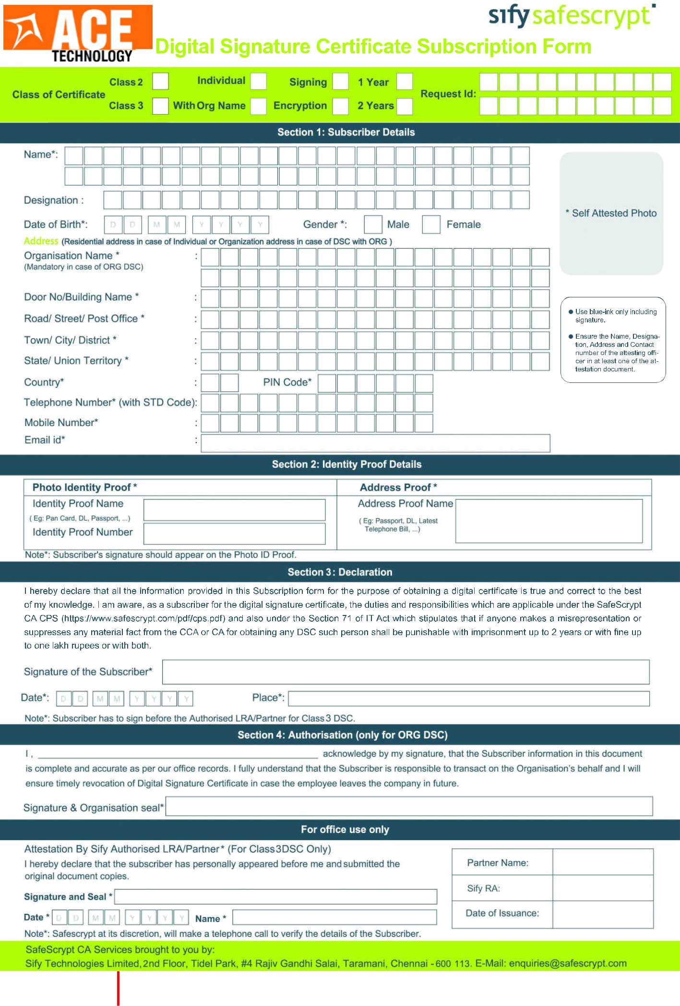
Enrollment Date :- ______________

Time :- ______________

LRA Contact Address : 37/320, Unnat Nagar 2, Opp. Patkar College,Inside Darshan Photo Studio lane,Goregaon(West), Mumbai - 400062.
Ace Technology | Tel.: 022 - 2876 3744/ 55 /66 | Website: www.acetechnology.co.in | Email Id: support@acetechnology.co.in

